Project Report

**Music Genre Classification with Parallelized Deep Learning**



Group 4: Ashish Roy (NUID: 001044804)

**CSYE 7105: High-Performance Parallel Machine Learning and AI**

**Table of Content**

1. **Introduction**
   1. Problem Statement
   2. Goal
2. **Methodology**
   1. Code Files
      1. data_path.py
      2. raw_data.py
      3. data_set_split.py
      4. model.py
      5. main.py
   2. Hardware Usage
   3. Model Architecture
3. **Description of Dataset**
   1. Dataset Files
   2. Classification Categories
   3. Dataset Link
4. **Results and Analysis**
   1. Constant Parameters
   2. Experimental Results
      1. Experiment 1
      2. Experiment 2
      3. Experiment 3
   3. Analysis
      1. PCA
5. **Conclusion**
6. **References**
7. **Introduction:**

The Genre of music is how we differentiate between different types of music. This classification is necessary for various applications and is used by top music distribution companies to recommend based on users’ likes and history.

* 1. **Problem Statement:**

It isn’t easy to classify music perfectly because we can classify them into various genres in varying ways. Music can also fit classification criteria for two genres like Hip-hop, Rock, and Jazz have influenced each other. Still, the use of instruments in different ways and their focus on a particular aspect distinguishes them. In Hip-hop, the focus is on the vocals; in Rock, it's the drums and guitar; and in Jazz, the focus is on instrumental harmony.

Since music files can be huge and classifying every music based on different elements can be computationally intensive and time-consuming, I propose a parallelized music genre classification with deep learning to overcome these challenges.

* 1. **Goal:**

The goal is to develop a parallelized model that accurately classifies the given music genre. Along with categorizing, the goal is to answer one crucial question:

* How much parallelism is too much parallelism for this model?

1. **Methodology:**

The audio files obtained cannot be used directly with any machine learning model. The first step is to transform the data into a numeric, vector, or tensor representation. The targeted classification must also be converted into a numeric representation so that the dataset can be fitted into the model to account for differences in individual categories.

The dataset can now be split into train, validation, and test sets to analyze the performance of our model.

* 1. **Code Files:**

The entire project is split into multiple files responsible for different parts of the project.

* + 1. data_path.py

Contains all the paths to the files necessary for the execution of the project.

* + 1. raw_data.py

This file converts our audio into a Mel-Spectrogram Log and returns a dataframe with two columns, i.e., spectrogram and genre, and saved in a file raw_data.pkl, which will be used in the future. Each spectrogram is of size (128, 128).

* + 1. data_set_split.py

This program uses raw_data.pkl file to perform a train test split, where the training, validation, and test sets into the following sizes:

x_train shape: (7000, 1, 128, 128)

y_train shape: (7000,)

x_valid shape: (2000, 1, 128, 128)

y_valid shape: (2000,)

x_test shape: (990, 1, 128, 128)

y_test shape: (990,)

It also encodes our genres using LabelEncoder.

* + 1. model.py

This file is the deep learning model of the project.

* + 1. main.py

This file uses Cuda to parallelize the processes on GPU.

* 1. **Hardware Usage**

Cluster: Discovery High-Performance Computing Cluster

Reservation: csye7105-gpu

Reservation Memory: 2GB

Time reserved: 4 hrs

GPU: Nvidia V100-SXM2

GPU Count: 1, 2 and 4

GPU Memory: 32GB/GPU

CPU: 1

Nodes: 1

* 1. **Model Architecture**

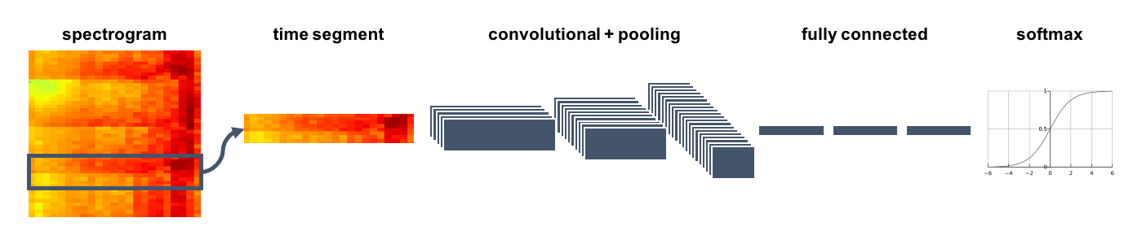

1. **Description of Dataset**
   1. **Dataset Files**

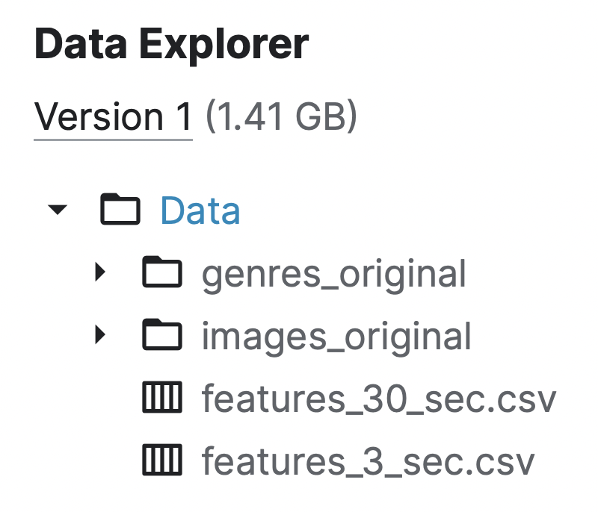 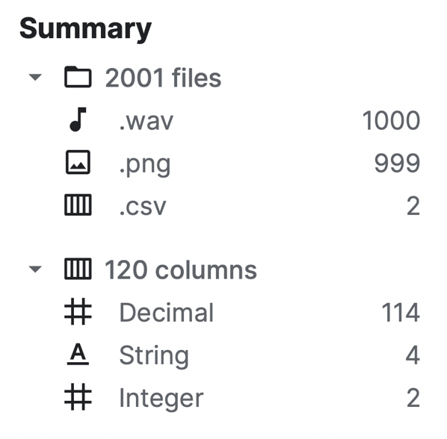

The total dataset file is sized at 1.41GB, comprising audio, spectrogram, and CSV files. Folder genres_original, which contains audio, is used for the project (1.33GB).

Sample file names:

blues.00002.wav disco.00008.wav pop.00038.wav rock.00022.wav

As seen above, the audio files are named in a format separated by ‘.’, where the first part is its genre. This makes it easier to map the data of Mel-Spectrogram Log to its genre for classification.

* 1. **Converted Dataset**

Here are some Mel-Spectrogram Logs of some of the classification genres.

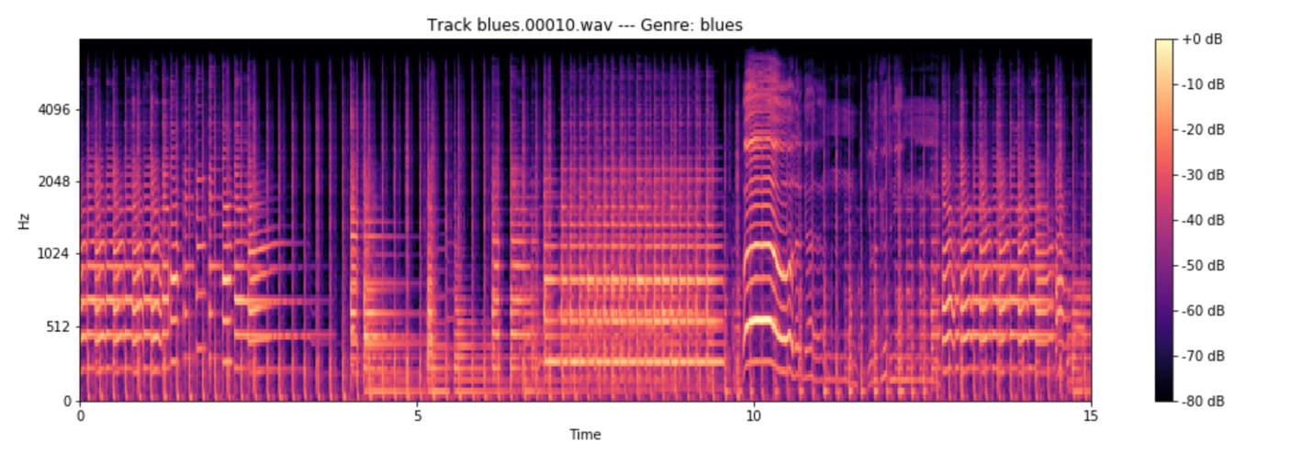

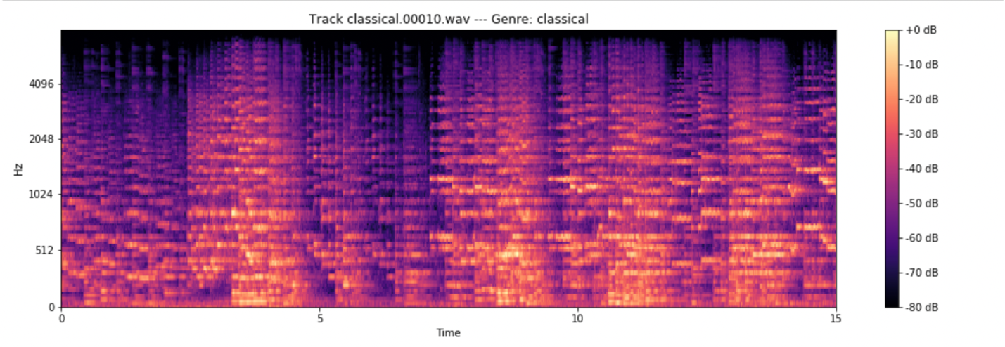

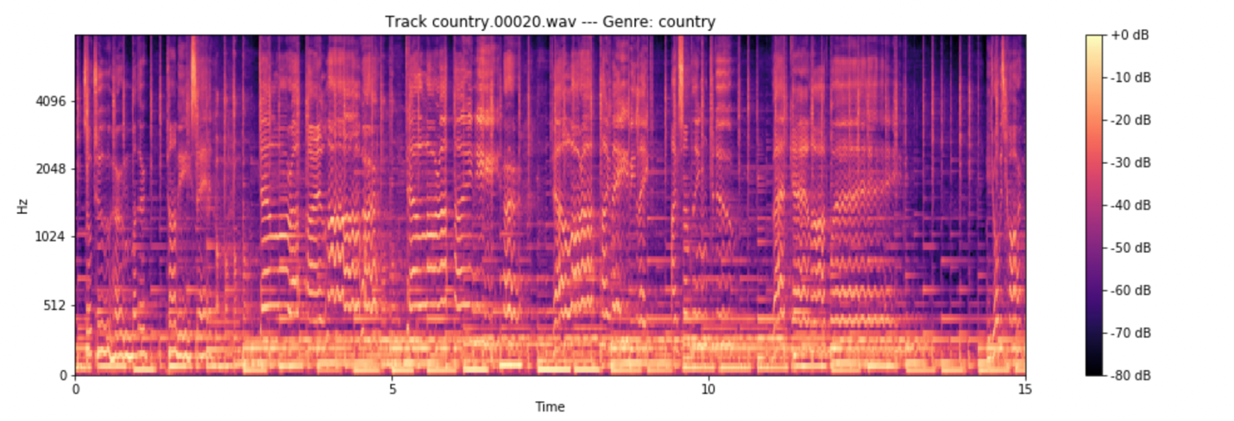

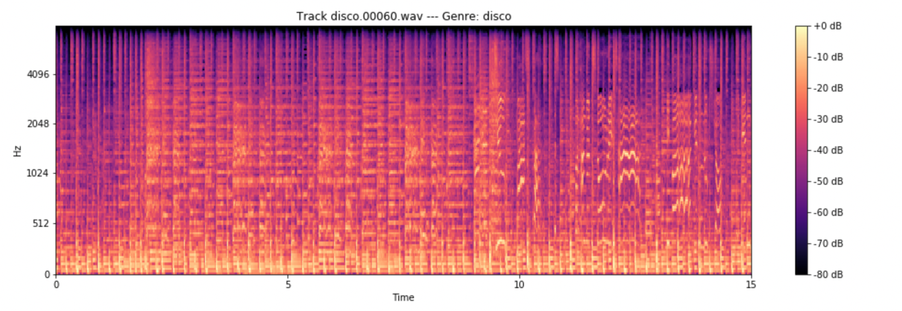

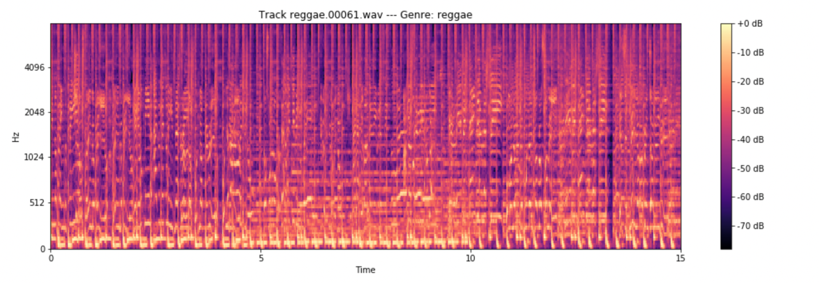

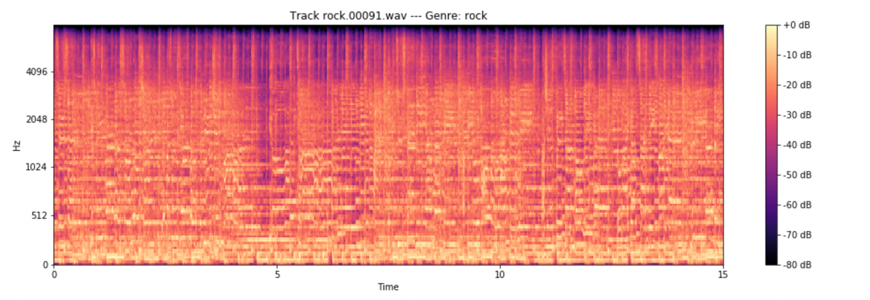

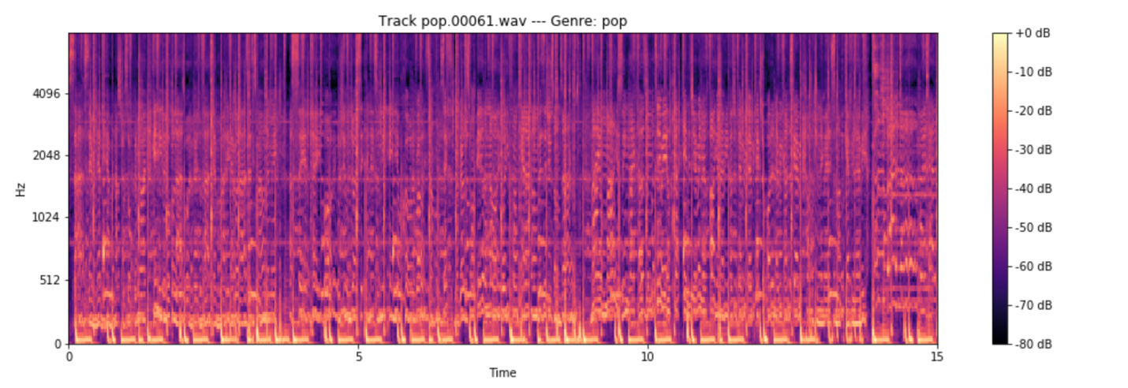

* 1. **Classification Categories**

There are ten categories which consist of 100 audio files each. Below is a list of our classification categories:

1. Blues
2. Classical
3. Country
4. Disco
5. HipHop
6. Jazz
7. Metal
8. Pop
9. Reggae
10. Rock
    1. **Dataset Link**

The dataset can be downloaded using [this link](https://www.kaggle.com/datasets/andradaolteanu/gtzan-dataset-music-genre-classification).

1. **Result and Analysis**
   1. **Constant Parameters**

* **Train Test Validation size:** This is kept constant to the shape mentioned previously.
* **Number of Epochs:** The number of epochs is set to 100 because of limited available time. The model performs at an accuracy of 96% when trained for 1200 epochs on one GPU but takes much time to execute. Similarly, it performs at 75% accuracy for 550 epochs but takes 47 min to complete.
* **Model Parameters:** All the model parameters are the same for all experiments. Changing this would affect the comparison of the parallel performance.
  1. **Experimental Results**
     1. **Experiment 1**

**GPU:** v100-sxm2

**No. of GPUs:** 1

**Reservation:** csye7105-gpu

**Epoch:** 100

**Batch Size:** 256

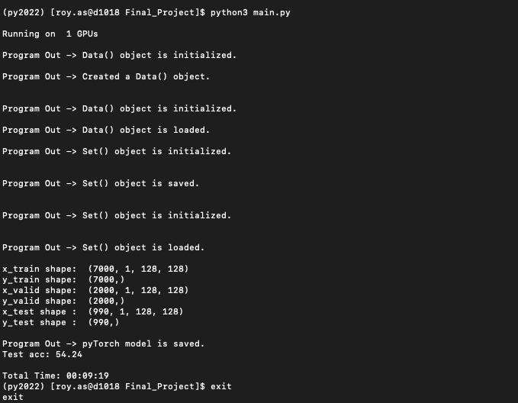

**Total Time:** 00:09:19

**Test Accuracy:** 54.24%

* + 1. **Experiment 2**

**GPU:** v100-sxm2

**No. of GPUs:** 2

**Reservation:** csye7105-gpu

**Epoch:** 100

**Batch Size:** 256

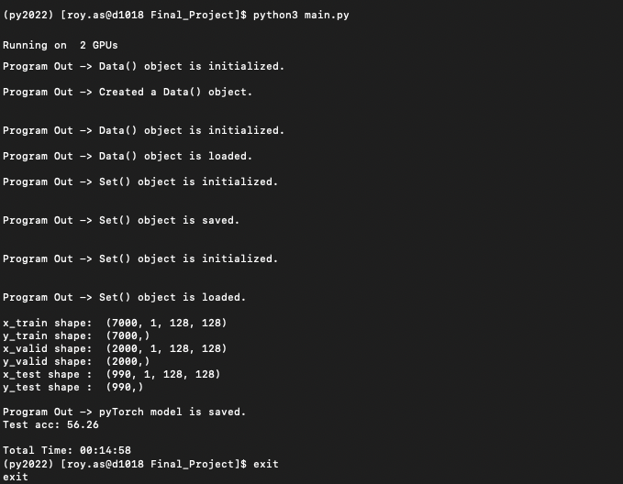

**Total Time:** 00:14:58

**Test Accuracy:** 56.26%

* + 1. Experiment 3

**GPU:** v100-sxm2

**No. of GPUs:** 4

**Reservation:** csye7105-gpu

**Epoch:** 100

**Batch Size:** 256

**Total Time:** Infinity

**Test Accuracy:** N/A

* 1. **Analysis**

|  |  |  |  |
| --- | --- | --- | --- |
| Experiment Number | Execution Time | Model Accuracy | No. of GPUs |
| 1 | 00:09:19 | 54.25% | 1 |
| 2 | 00:14:48 | 56.26% | 2 |
| 3 | Infinity | N/A | 4 |

**Insights:**

* It is evident that increasing the GPU number increases the model accuracy
* But increasing the number of GPUs exponentially increases the execution time
* It fails to execute on 4 GPU

To further understand what causes this exponential growth in execution time, I performed a Principal Component Analysis on the dataset.

* + 1. PCA

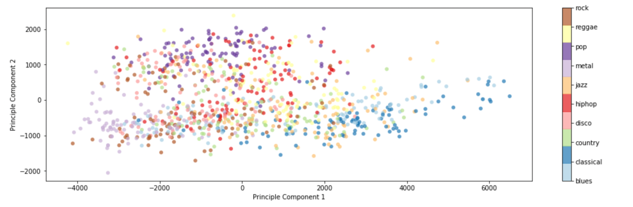

The scatter plot clearly shows that the dataset can be classified into their genres, but how many components are required to classify them accurately?

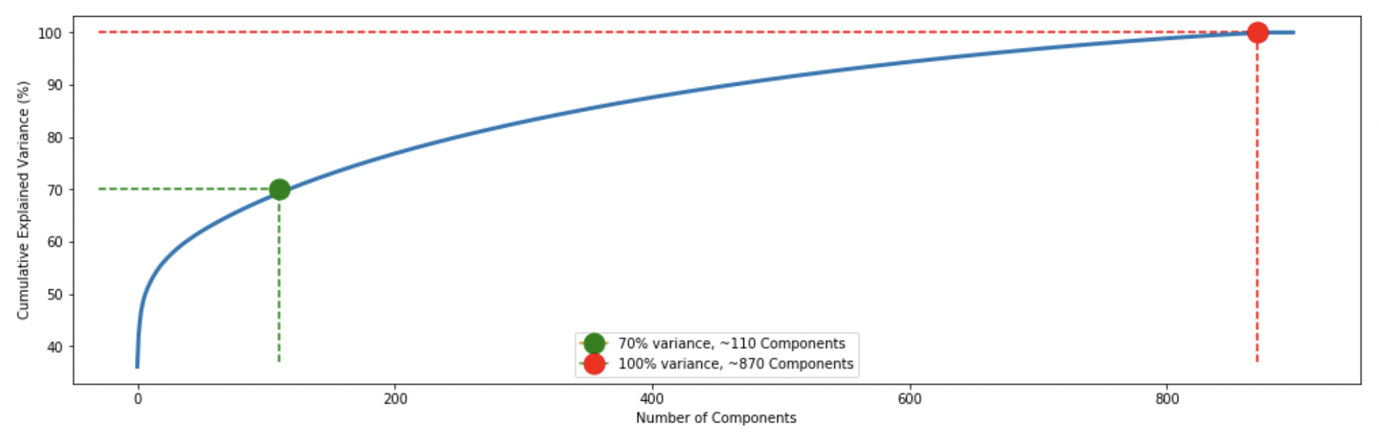

Approximately 110 components explain 70% of the variance from the plot, and around 950 components explain 100%. We can also see that the remaining components define none of the variances. The plot suggests that we should perform PCA before using any neural network model. By performing PCA, we will only use the components that define the variance of our classification.

1. **Conclusion**

To classify the music genre perfectly, it is essential only to take components contributing to the model performance. If the aim is to classify music with an accuracy of 90%, only 410 components are required to do so and can perform best at 1 GPU as well.

**References:**

* <https://towardsdatascience.com/how-to-apply-machine-learning-and-deep-learning-methods-to-audio-analysis-615e286fcbbc>
* <https://stackoverflow.com/questions/65179954/should-a-data-batch-be-moved-to-cpu-and-converted-from-torch-tensor-to-a-numpy>
* <https://deeplizard.com/learn/video/Bs1mdHZiAS8>
* <https://pytorch.org/docs/stable/generated/torch.nn.Module.html>
* <https://arxiv.org/abs/1712.08370>
* <https://ieeexplore.ieee.org/document/8554016>
* Oramas S, Barbieri F, Nieto O, Serra X. Multimodal deep learning for music genre classification. Transactions of the International Society for Music Information Retrieval. 2018;1(1):4-21. DOI: 10.5334/tismir.10